Histograms

A histogram is a graph. A graph that shows frequency of anything. Usually histogram have bars that represent frequency of occurring of data in the whole data set.

A Histogram has two axis the x axis and the y axis.

The x axis contains event whose frequency you have to count.

The y axis contains frequency.

The different heights of bar shows different frequency of occurrence of data.

Usually a histogram looks like this.

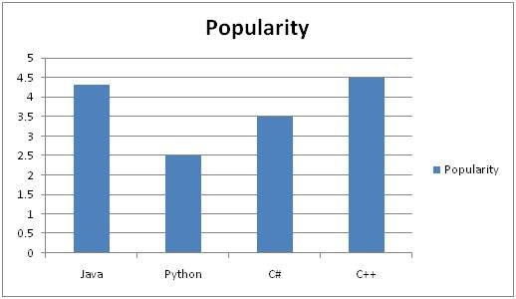

Now we will see an example of this histogram is build

Example

Consider a class of programming students and you are teaching python to them.

At the end of the semester, you got this result that is shown in table. But it is very messy and does not show your overall result of class. So you have to make a histogram of your result, showing the overall frequency of occurrence of grades in your class. Here how you are going to do it.

Result sheet

|  |  |
| --- | --- |
| **Name** | **Grade** |
| John | A |
| Jack | D |
| Carter | B |
| Tommy | A |
| Lisa | C+ |
| Derek | A- |
| Tom | B+ |

Histogram of result sheet

Now what you are going to do is, that you have to find what comes on the x and the y axis.

There is one thing to be sure, that y axis contains the frequency, so what comes on the x axis. X axis contains the event whose frequency has to be calculated. In this case x axis contains grades.

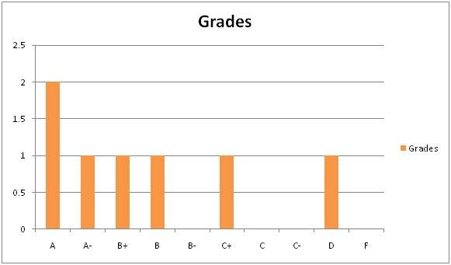

Now we will how do we use a histogram in an image.

Histogram of an image

Histogram of an image, like other histograms also shows frequency. But an image histogram, shows frequency of pixels intensity values. In an image histogram, the x axis shows the gray level intensities and the y axis shows the frequency of these intensities.

For example

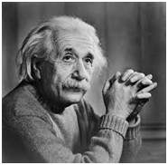

The histogram of the above picture of the Einstein would be something like this

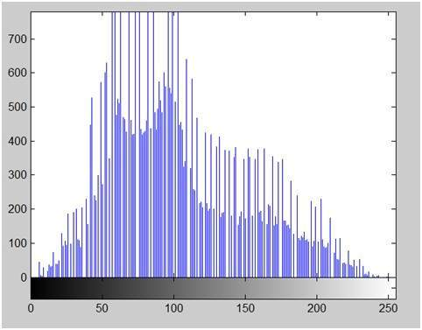

The x axis of the histogram shows the range of pixel values. Since its an 8 bpp image, that means it has 256 levels of gray or shades of gray in it. Thats why the range of x axis starts from 0 and end at 255 with a gap of 50. Whereas on the y axis, is the count of these intensities.

As you can see from the graph, that most of the bars that have high frequency lies in the first half portion which is the darker portion. That means that the image we have got is darker. And this can be proved from the image too.

Applications of Histograms

Histograms has many uses in image processing. The first use as it has also been discussed above is the analysis of the image. We can predict about an image by just looking at its histogram. Its like looking an x ray of a bone of a body.

The second use of histogram is for brightness purposes. The histograms has wide application in image brightness. Not only in brightness, but histograms are also used in adjusting contrast of an image.

Another important use of histogram is to equalize an image.

And last but not the least, histogram has wide use in thresholding. This is mostly used in computer vision.

Brightness

Brightness is a relative term. It depends on your visual perception. Since brightness is a relative term, so brightness can be defined as the amount of energy output by a source of light relative to the source we are comparing it to. In some cases we can easily say that the image is bright, and in some cases, its not easy to perceive.

For example

Just have a look at both of these images, and compare which one is brighter.

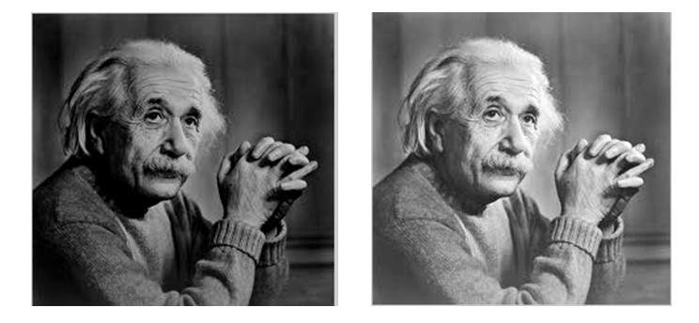

We can easily see, that the image on the right side is brighter as compared to the image on the left.

But if the image on the right is made more darker then the first one, then we can say that the image on the left is more brighter then the left.

How to make an image brighter.

Brightness can be simply increased or decreased by simple addition or subtraction, to the image matrix.

Consider this black image of 5 rows and 5 columns



Since we already know, that each image has a matrix at its behind that contains the pixel values. This image matrix is given below.

|  |  |  |  |  |
| --- | --- | --- | --- | --- |
| 0 | 0 | 0 | 0 | 0 |
| 0 | 0 | 0 | 0 | 0 |
| 0 | 0 | 0 | 0 | 0 |
| 0 | 0 | 0 | 0 | 0 |
| 0 | 0 | 0 | 0 | 0 |

Since the whole matrix is filled with zero, and the image is very much darker.

Now we will compare it with another same black image to see this image got brighter or not.

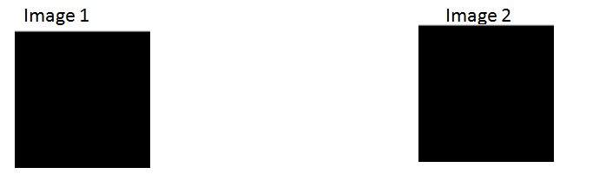

Still both the images are same, now we will perform some operations on image1 , due to which it becomes brighter then the second one.

What we will do is, that we will simply add a value of 1 to each of the matrix value of image 1. After adding the image 1 would something like this.



Now we will again compare it with image 2, and see any difference.



We see, that still we cannot tell which image is brighter as both images looks the same.

Now what we will do, is that we will add 50 to each of the matrix value of the image 1 and see what the image has become.

The output is given below.



Now again, we will compare it with image 2.



Now you can see that the image 1 is slightly brighter then the image 2. We go on, and add another 45 value to its matrix of image 1, and this time we compare again both images.

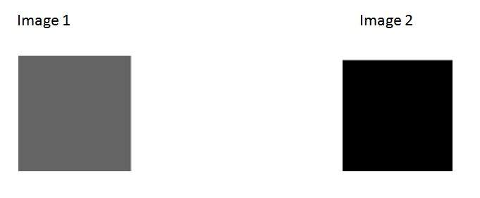

Now when you compare it, you can see that this image1 is clearly brighter then the image 2.

Even it is brighter then the old image1. At this point the matrix of the image1 contains 100 at each index as first add 5, then 50, then 45. So 5 + 50 + 45 = 100.

Contrast

Contrast can be simply explained as the difference between maximum and minimum pixel intensity in an image.

For example.

Consider the final image1 in brightness.



The matrix of this image is:

|  |  |  |  |  |
| --- | --- | --- | --- | --- |
| 100 | 100 | 100 | 100 | 100 |
| 100 | 100 | 100 | 100 | 100 |
| 100 | 100 | 100 | 100 | 100 |
| 100 | 100 | 100 | 100 | 100 |
| 100 | 100 | 100 | 100 | 100 |

The maximum value in this matrix is 100.

The minimum value in this matrix is 100.

Contrast = maximum pixel intensity(subtracted by) minimum pixel intensity

= 100 (subtracted by) 100

= 0

0 means that this image has 0 contrast.

### Histogram sliding

In histogram sliding, we just simply shift a complete histogram rightwards or leftwards. Due to shifting or sliding of histogram towards right or left, a clear change can be seen in the image.

Sliding Histograms

Increasing brightness using histogram sliding



Histogram of this image has been shown below.

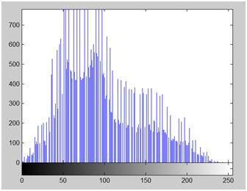

On the y axis of this histogram are the frequency or count. And on the x axis, we have gray level values. As you can see from the above histogram, that those gray level intensities whose count is more then 700, lies in the first half portion, means towards blacker portion. Thats why we got an image that is a bit darker.

In order to bright it, we will slide its histogram towards right, or towards whiter portion. In order to do we need to add atleast a value of 50 to this image. Because we can see from the histogram above, that this image also has 0 pixel intensities, that are pure black. So if we add 0 to 50, we will shift all the values lies at 0 intensity to 50 intensity and all the rest of the values will be shifted accordingly.

Lets do it.

Here what we got after adding 50 to each pixel intensity.

The image has been shown below.

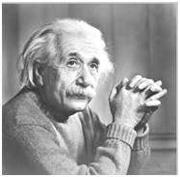

And its histogram has been shown below.

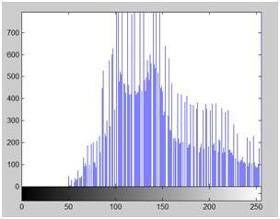

Lets compare these two images and their histograms to see that what change have to got.

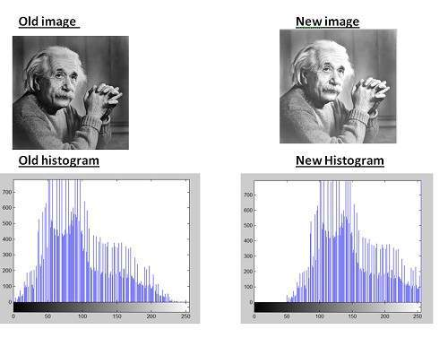

Conclusion

As we can clearly see from the new histogram that all the pixels values has been shifted towards right and its effect can be seen in the new image.

Decreasing brightness using histogram sliding

Now if we were to decrease brightness of this new image to such an extent that the old image look brighter, we got to subtract some value from all the matrix of the new image. The value which we are going to subtract is 80. Because we already add 50 to the original image and we got a new brighter image, now if we want to make it darker, we have to subtract at least more than 50 from it.

And this what we got after subtracting 80 from the new image.

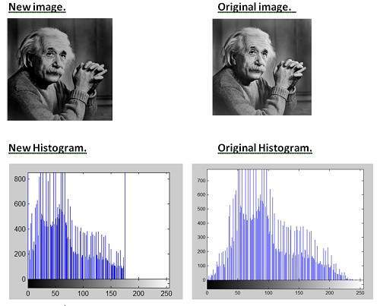

Conclusion

It is clear from the histogram of the new image, that all the pixel values has been shifted towards right and thus, it can be validated from the image that new image is darker and now the original image look brighter as compare to this new image.